



Computer Communications 28 (2005) 829–836

www.elsevier.com/locate/comcom

Multiple path routing algorithm for IP networks

Miguel Rios*, Vladimir Marianov, Andres Avagliano
Department of Electrical Engineering, Universidad Catolica de Chile, Vicuna Mackenna 4860, Casilla 306, Correo 22, Santiago 6904411, Chile
Received 16 June 2003; revised 4 November 2004; accepted 24 November 2004
Available online 20 December 2004

Abstract
Internet routing protocols, such as Open Shortest Path First (OSPF), compute a shortest path tree from each node to other nodes in the
network, using link-state information. Such protocols do not consider the queueing situation at a given node. An alternate path of higher cost
may be more convenient to use than the optimum path when a long queue is present at the node. This paper proposes a new Multiple Path
Routing Algorithm (MPRA), which uses dynamic shortest path tree mechanisms, load balancing among alternative paths to destination, and
path feasibility analysis to avoid network loops. A better-cost model is also introduced. Computer simulations show that MPRA measured
parameters (throughput, packet delay, etc.) improve over OSPF by amounts close to 30% for unbalanced networks, and close to 20% for
balanced networks.
q 2004 Elsevier B.V. All rights reserved.

Keywords: Dynamic routing; Load balancing; Network routing

1. Introduction

In today’s IP networks, routing protocols are responsible
for building a path that will carry a data packet to its
destination [1]. Each router in the network has to send the
packet to its next hop, independently from what other
routers are doing at the time, on rules based only on its own
knowledge base. These routing tables are built based on
topological and trafﬁc information, send or captured from
information being received from other routers. This paper
focuses on ﬁnding improvements to the Open Shortest Path
First (OSPF) routing protocol [7,9]. OSPF is a link-state
based routing protocol, which ﬁnds the shortest (minimum
cost) path for a data packet through the network [10], using
the cost associated to each link. In most cases, however,
there are alternative paths to the destination that, even if
they are not optimum, have available capacity that could be
used to improve the total network throughput.
This paper proposes a new cost model for evaluating the
network links and a new dynamic algorithm for the
re-routing of packets, that implements data load balancing,
by way of using alternate paths to a given destination.

* Corresponding author. Tel.: C56 23544291; fax: C56 25522563.
E-mail address: mrios@ing.puc.cl (M. Rios).
0140-3664/$ - see front matter q 2004 Elsevier B.V. All rights reserved.
doi:10.1016/j.comcom.2004.11.014

Furthermore, we analyse the feasibility of sending a packet
for each link using a shortest path compatible criterion. The
new algorithm is called Multiple Path Routing Algorithm or
MPRA.
The paper is organised as follows: in Section 2 a short
background on the routing subject is given. Section 3
discusses some previous work, which is used to build the
new algorithm. Section 4 explains the cost model used in
the algorithm. Section 5 gives implementation details of the
MPRA algorithm. Section 6 presents computer simulation
results showing the improvements that MPRA offers with
respect to OSPF. Finally Section 7 presents the conclusions
of this work.

2. Background

In packet switching networks, such as the Internet, a
packet goes to its destination through several intermediate
nodes. When a given packet reaches a router, a routing
protocol determines which output link should be used for
sending the data to the next hop.
Each link between two routers has an associate cost,
which can be used to calculate the best path to use to get to
the packet destination from a given router. Usually these

830

M. Rios et al. / Computer Communications 28 (2005) 829–836

costs, independently of how they are calculated, are
considered static through time, and each router provider
establishes its own way of calculating them depending, at
least, on the link available bandwidth [2].
But, in the real world, costs are not ﬁxed as assumed but
dynamic, depending not only on the physical characteristics
of each link, but also on the load or other variables of the
network. This is the scenario, where this paper proposes a
path cost model, allowing a better discrimination on the
packet next hop to follow.
On the other hand, when the optimum output link is
congested, the marginal cost of transmitting the packet
through that link is very high, due to the queueing nature of
a congested link operating near its capacity. In this situation,
sending the packet through an alternate path can be very
attractive in terms of the total cost. The proposed MPRA
algorithm uses this fact, in such a way that each router will
distribute the trafﬁc load among several output links (with
available capacity) that can take the load to their destination.
One of the advantages of the proposed algorithm is that it is
based on the same algorithm (Shortest Path First or SPF)
that is used by the OSPF protocol.
Finally, the next hop output link has to be chosen
carefully since, the same as in link-state based routing
protocols like OSPF, the chosen path must guarantee it will
not produce undesirable loops.

3. Related work

4. Cost model

In this paper, we ﬁrst ﬁnd a cost model that is useful for
characterising an output link. The model has to be matched
to the basic trafﬁc characteristics of a channel, besides
reasonably representing the physical limitations of the
channel. A linear approximation was ﬁnally used to reduce
the computation time in routers, using only those iterations
that are strictly necessary, and without losing any useful
information. After ﬁnding this approximate model, a basic
criterion is proposed to perform the load balancing among
the output links.
Finally, some priority logic is used to select among
candidate output links for the next hop because, at the time
of balancing the load, there are several alternate paths and,
generally (because of congestion), the optimum output link
will not necessarily be used, given the shortest distance
criterion used by OSPF. These chosen paths should be
feasible and should not produce loops in the network.

4.1. Queueing model

Since a transmission line K times as fast will accommo-
date K times as many packets/s at K times smaller average
delay per packet¹, costs in the Internet are generally
assigned as being inversely proportional to the channel
bandwidth [7], that is:
BW_{ref}

C Z
BW
(1)

There have been several previous efforts to improve the
network routing algorithms, both in time and space. This
paper follows the study done by Narvaez [3,4], which
proposed several improvements in different stages of the
routing process. One of the most important proposals is
changing the current static SPF algorithms (such as
Bellman-Ford, Dijkstra and D’Esopo-Pape [5]) into
dynamic algorithms. On the other hand, Narvaez proposed
a routing protocol limiting the amount of information to be
transmitted through the network and a routing algorithm that
where C is the channel cost, BW_{ref}is the reference
bandwidth of network channel [2,8], and BW is the real
link bandwidth. It can also be observed that the cost is
related to both the waiting and service time of the packet
being transmitted.
Other cost representations may include the delay cost.
For instance, when dealing with satellite links, the following
formula has been suggested:
BW_{ref}

search for multiple paths to a destination.
Some other studies related to multiple path routing
C Z K₁!
BW^{C}
р_{K}2 !DelayЮ
(2)

include the Flow Deviation Algorithm (FD) [16] and the
Bertsekas-Gallager Algorithm (BG) [6]. Both algorithms
minimise the average delay through the packet path. These
algorithms, after several iterations, tend to a state with a
shortest delay on average. One of the problems of these
algorithms is that they use information from the entire
network at all times, so the routing information, about the
link congestion on the network, circulating among nodes is
very large and contributes to the network congestion. Both
FD and BG were designed to work in virtual circuit
networks, which calculate the routing in a centralised way,
heavily incrementing the amount of information (overhead)
and delay to deliver the routing information to all the routers
in the network.
where K₁and K₂are weighing coefﬁcients. In Eqs. (1) and
(2), cost is considered ﬁxed over the network operation
time. The cost can only be changed when a given link fails,
or a new link is added to the network, or any topological
change in the network is produced.
In the real world, costs are not ﬁxed but depend on the
queueing model being used. Generally speaking, the output
link cost can be related to the total time (T) the packet stays
at a node, which is the sum of the service (or transmission)
time (T_{S}) and the queueing waiting time (T_{W}) or queueing
delay. This total time has been modelled as a M/M/1
Markov Chain [6,11,12], where data packet arrivals are

1
[17].

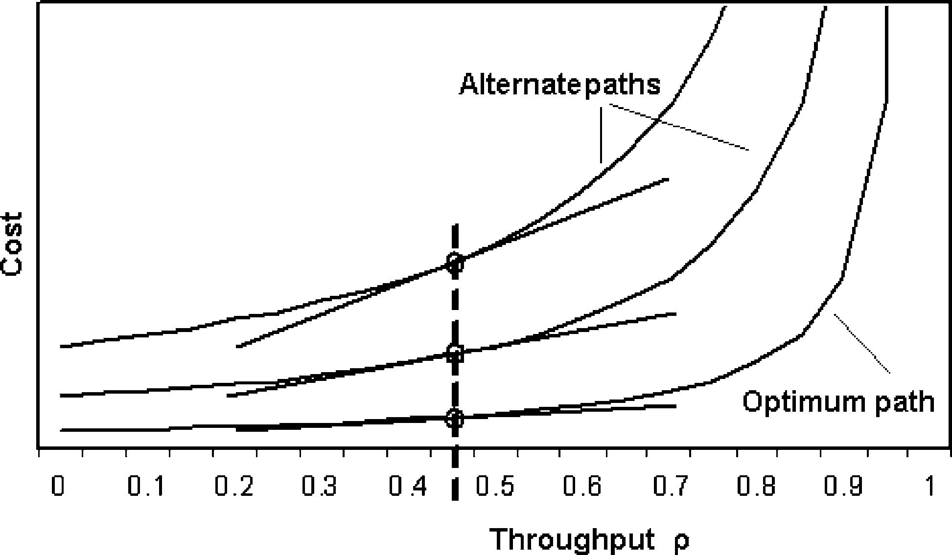
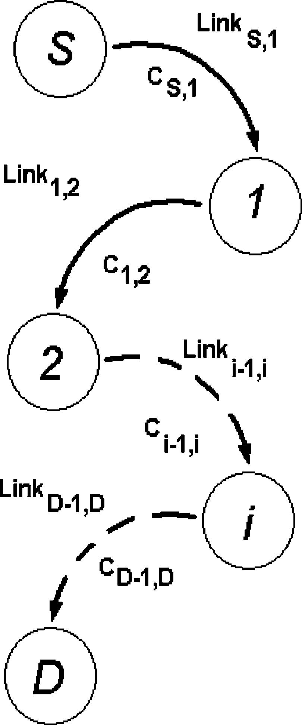
M. Rios et al. / Computer Communications 28 (2005) 829–836

assumed independent with exponential interarrival time
distributions, according to Burke’s theorem.
If l is the average packet arrival rate, and T_{S}Z1/m is the
average packet transmission rate, then by Little’s Theorem
the node throughput r is given by:
r Z lT_{S}Z l=m (3)
It follows then that the total time the packet stays at a node
(both waiting and in service) is given by [6]:
T Z T_{S}C T_{W}Z 1=m !1=р1 K rЮ Z T_{S}=р1 K rЮ (4)
where T_{S}, as it was mentioned before, is related to the ﬁxed
cost C_{F}through:
C_{F}Z BW_{ref}!T_{S}Z K !T_{S}(5)
Now, if several output links exist at a node, these links can
be seen as independent queues. An example of three output
link queues is shown in Fig. 1.
When the output link is used at a small capacity (say
r!0.5 in Fig. 1), the cost versus r is almost constant. This
value is called ﬁxed cost or C_{F}, which depends on the Fig. 2. Path example.
physical characteristics of the link. On the other hand, when

831

the amount of information being carried approaches the
capacity of the channel, the cost raises due to the congestion
related to the trafﬁc load of the channel. This cost will be
called variable cost or C_{V}.
Relating, as before, variable costs with the queue waiting
time T_{W}, and assuming all packets through the node request
the same service type, then

C_{V}Z K !N_{q}!T_{S}(6)
where K is a constant with the same functionality as BW_{ref}
and N_{q}ZlT_{W}is the number of packets in queue waiting to
be transmitted. Then the total cost for the node output link is
given by
C_{L}Z C_{F}C^{C}V (7)

C_{L}Z K!T_{S}C^{K}!^{N}q !^{T}S Z K!T_{S}!^{р}N_{q}C¹Ю (8)
where the ﬁrst term explains the physical characteristics of
the link and the second the link trafﬁc load.
4.2. Proposed cost model

From the previous discussion, the new cost model is
based in the following assumptions:

1. Burke’s Theorem reasonable represents the link trans-
mission capacity².
2. The output link cost can be modelled as the sum of a
ﬁxed cost and a variable cost, where the ﬁxed cost is
determined by the physical structure of the links in the
path and is calculated using the current SPF algorithm,
and the variable cost is determined by the node output
link cost and its utilisation at a given time.
3. The variable cost represents the output link trafﬁc load
and is a good estimation of the complete path load to the
destination.

In Fig. 2 it can be seen, according to the assumptions,
that if SPF delivers the shortest path between a source S
and a destination D, then the path cost is the sum of
every link cost in that path, which would be given by:

C_{T}Z C_{S};1 CC₁;2 C. CC_{i}K¹;i C . C C_{D}K¹;D
X^{K}1

Z
jZS
C_{j};jC1 Z C_{V}C C_{F}
(9)

From Eq. (8) we observe that:

C_{L}Z K!T_{S}!^{р}N_{q}C¹Ю_{Z}Cqueue C^{C}S;1

(10)

Fig. 1. Link throughput curves for a three-output link node.

2 From Kleinrock’s assumptions, see pp. 147–160 of [11] and pp. 314–329
of [12].

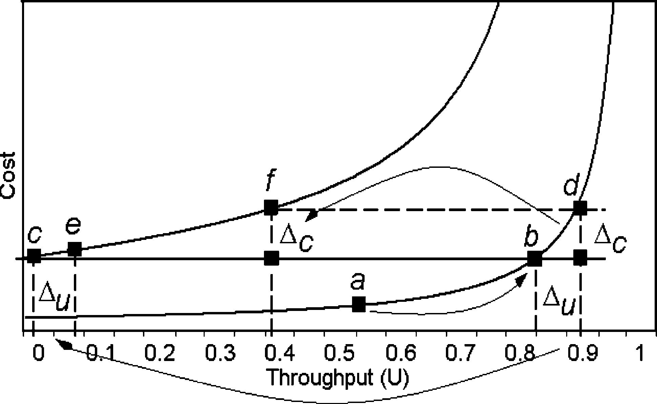
832

M. Rios et al. / Computer Communications 28 (2005) 829–836

By the third assumption, C_{L}is the cost of the next hop from
the source node and represents a good estimation of the
complete path load to the destination. Then the total cost of
the path not including the ﬁrst hop, CREM, is given by:
X_{K}1
C_{REM}Z C_{j};jC¹K^{C}S;1 (11)
jZS
The total cost of the path is then given by
C_{T}Z C_{L}CC_{REM}

For each node X, the ﬁrst input in the data structure
contains the shortest distance d_{opt}(S,X) found so far. This
information is computed using the Dijkstra algorithm in
OSPF. Furthermore, the cost w(S,p) for every output link
connecting the node S to node p is also maintained in the
structure, as well as the shortest distance to the destination
through that node p, that is d_{p}(S,X). When the algorithm
ends, d_{p}(S,X) should be larger or equal than the sum of
w(S,p) and the shortest distance d(p,X) from p to X.

C_{T}Z рCqueue C C_{S};1^{Ю}C
X_{K}1

jZS

C_{j};jC¹K C_{S};1
!

(12)
4.4. Feasibility test

To check which are the next feasible hops without loops,

C_{T}Z Cqueue C
X_{K}1

jZS

C_{j};jC¹Z N_{q}!C_{S};1 C
X_{K}1

jZS

C_{j};jC¹
the following test is performed.
If d_{p}рS; XЮ!рd_{opt}рS; XЮ

Finally the cost model for the complete path is:
CwрS; pЮЮ; then p is a feasible next hop:
(14)

C_{T}Z K !N_{q}!T_{S}C
X_{K}1

jZS

C_{j};jC¹

(13)
The test ensures the distance to the destination decreases
monotonically, hence a packet will never return to a node
twice.

where C_{j,j}C1 is the link cost used in the OSPF protocol.
This equation shows that a part of the cost depends on the
OSPF costs (typically assigned by the users) and the other
part depends on the trafﬁc load from the.

4.3. Next feasible hops

The routing algorithm through alternate paths has to
comply with the following:

† The alternate path should be the second best to the
optimal one and without loops.
† The decision on the path to be followed by the packet at a
given node should be based only on local information
available at that node.
† The congestion state of each output link has to be taken
into account, as well as the cost of the path to the
destination.

This paper uses as a starting base the Narvaez Algorithm
[3,4], called MPA, to select the next feasible hop. This
algorithm uses an efﬁcient data structure plus the basic SPF
algorithm, checking and registering on each iteration the
necessary information about alternate paths to the destina-
tion. This algorithm was chosen since the objective is to
improve the re-routing system using only a more efﬁcient
local and dynamic decision. The data structure used by the
MPA algorithm is as follows:
The path without loops policy is then as follows: if router
S sends a packet with destination R₂to its next hop R₁, then:
dрR₁; R₂Ю!dрS; R₂Ю (15)

4.5. Next hop choosing

Similarly to OSPF, the objective is to ﬁnd the shortest
path to destination. To that purpose the costs are compared
and the next hop of minimum cost will be chosen. Fig. 3
shows an example of how this is done.
In Fig. 3 for a given throughput U, the curve with lower
cost corresponds to the shortest path to the destination. Of
course if U is high (as in congested systems) the cost will
tend to inﬁnity, even in the optimum path. The costs when
UZ0, correspond to the OSPF design criterion.
The trafﬁc load balancing should be done precisely when
the throughput U of the optimum path reaches the ﬁxed cost
of the next alternate path (point b in Fig. 3, where the curve
cost represents the alternate paths in terms of costs).

Shortest dis-
tance from node
S to node X

d_{opt}(S,X)
Next hop
Hop S/A
Hop S/B
Hop S/C
Hop S/D
.
Link cost
w(S,A)
w(S,B)
w(S,C)
w(S,D)
.
Distance
d_{A}(S,X)
d_{B}(S,X)
d_{C}(S,X)
d_{D}(S,X)
.

Fig. 3. Throughput curves showing the load balancing process.

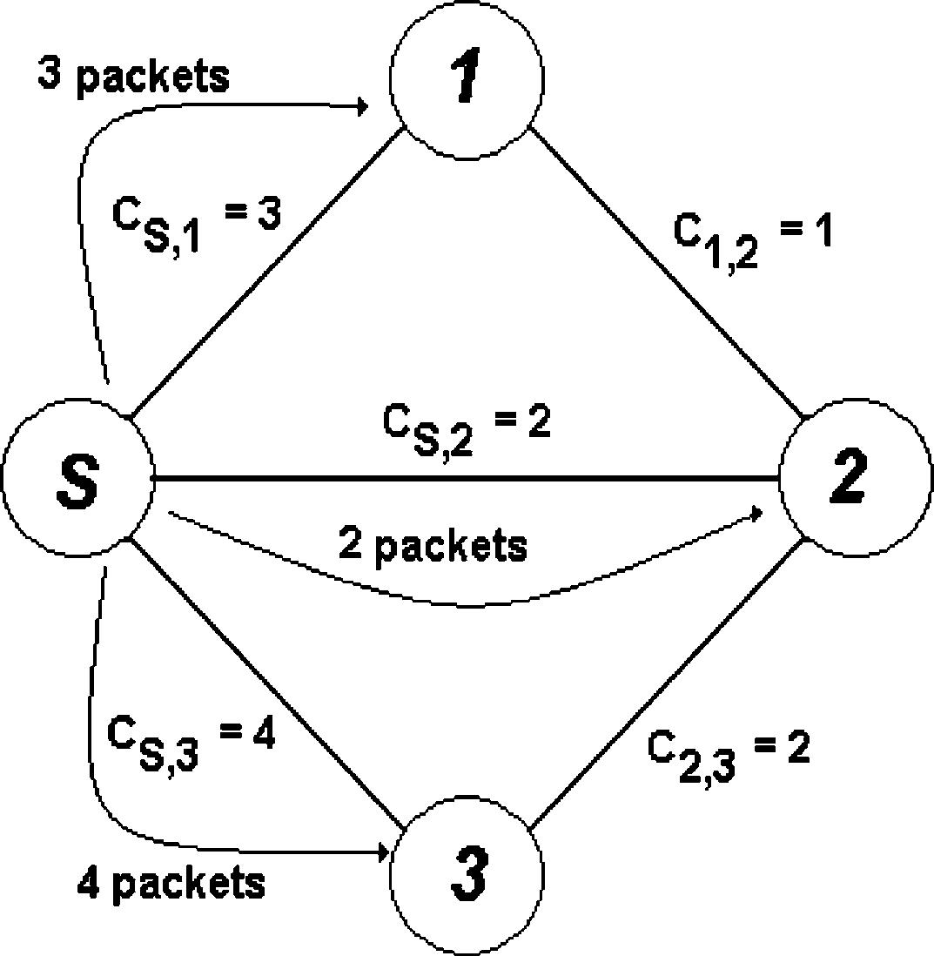
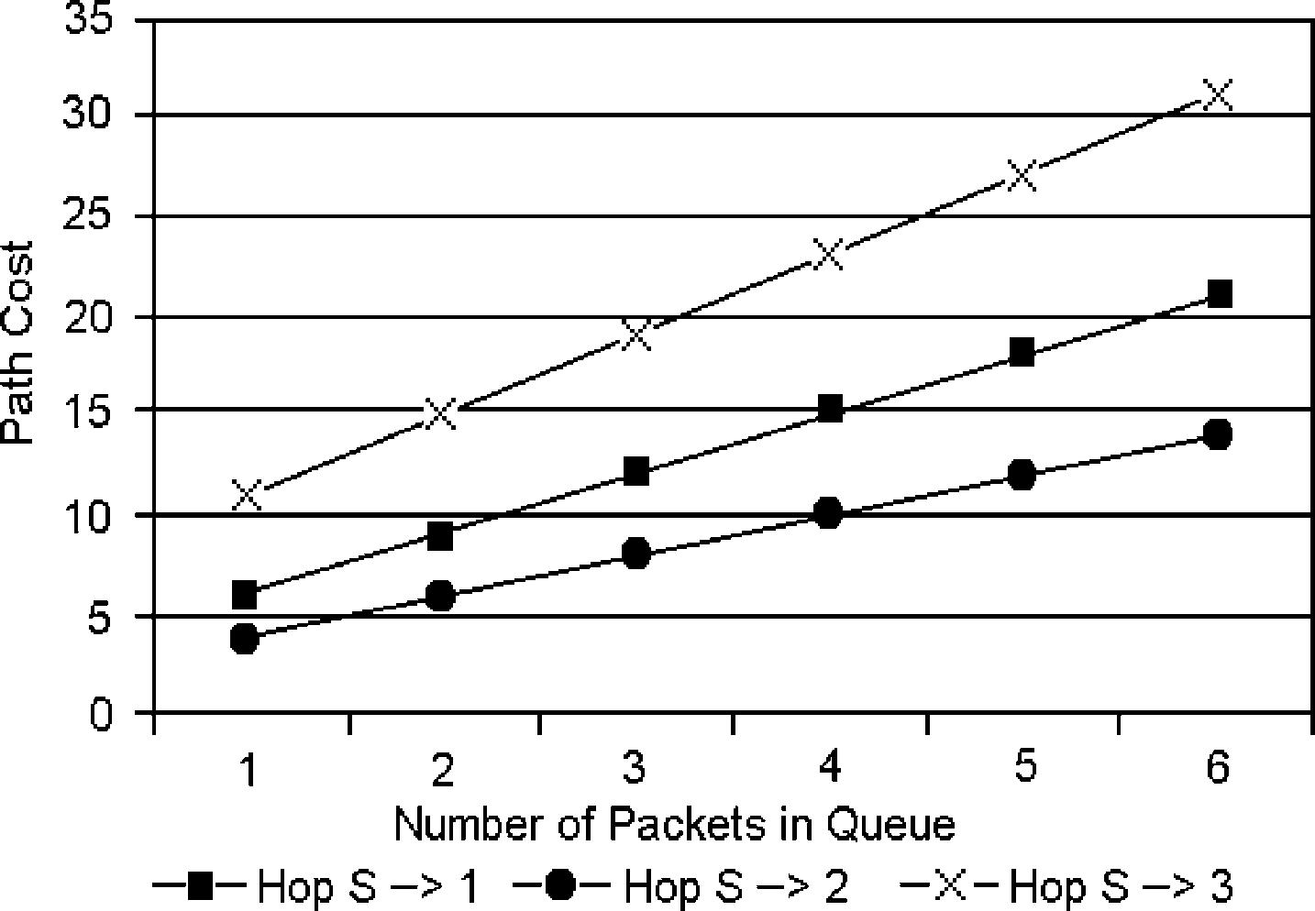
M. Rios et al. / Computer Communications 28 (2005) 829–836

Table 3
Routing table construction example

833

Link hop
No. of
Path
Path cost C_{T}Z NC_{S};X C

S/X
packets (N)
P
j2PATH^{C}j;jC1

Hop S/1 3
Hop S/2 2
S/1
S/2/1
12
7

Hop S/3 4
S/3/2/1 23

Fig. 4. Four node network example showing costs and packet load.

In Fig. 3, moving from point b to d implies a throughput
difference Du with a cost difference of Dc. The option at this
time is placing Du in the alternate path, i.e. moving from
point c to point e with same Du, or moving from point c to
point f with same Dc. In this paper we adopted the ﬁrst
approach, that is, to move the difference Du to other
alternate path. It is clearly seen from Fig. 3 that point e has a
lower cost than point d and so provides a better solution.
The balancing process can be shown, as an example, for
the network of Fig. 4.

5. Mathematical formulation of MPRA

As mentioned before, MPRA is comprised of the MPA
algorithm plus the proposed cost model plus the load-
balancing algorithm. The model is shown in Fig. 6,
compared with OSPF.
The MPRA operation depends on the information
delivered by the MPA algorithm, stored at each node in
the MPA routing table, as it was explained in Section 4.3.
The mathematical formulation of the model is very
simple, being as follows:
We have shown the total cost of a given path from a
given source node to be

X_{K}1

Table 1 shows the data structure for the example with
next hops to node 1 from node S, calculated by the MPA
algorithm (S/1, S/2 y S/3).
C_{T}Z K!N_{q}!^{T}S C

jZS
C_{j};jC¹
(16)

OSPF would use hop S/1 as next hop to node 1, with
cost 3. OSPF also would take hop S/2, since it has the
same total cost 3 to node 1. Let assume the number of
packets at a given time in the queues is given as in Table 2.
Then it follows the costs of the different paths to node 1
would appear as those shown in Table 3.
It follows that the shortest lowest cost path to node 1, in
this scenario, should use S/2 as next hop.
Fig. 5 shows the three alternate paths to node 1, in terms
of the number of packets in queue. It follows that the best
We point out that all the necessary information to calculate
this cost is known at the node, from the MPA routing table
and the knowledge of the queue length of the output link.
Hence the MPRA algorithm running at the source node
should select, from all the available alternate paths to the
destination node, that path k of minimum total cost C_{T},k,
that is:
Minimize C_{T},k
s.a.
X

hop is S/2.

Table 1
Cost example

Shortest distance from
router S to node 1

d_{opt}(S,1)

Table 2
Packets in queue example

Next hop
Hop S/1
Hop S/2
Hop S/3
Hop S/1

W(S,P) dp(S,X)
3 3
2 3
4 7
3 3
C_{T};k Z K!N_{q};k !^{T}S;k C^{K}!

With kZ1,.,n and KO0

j2MPA_{k}
Ts_{j}
(17)

Link
Hop S/1
Hop S/2
Hop S/3
No. of packets in the queue
3
2
4

Fig. 5. Cost versus packet queue.

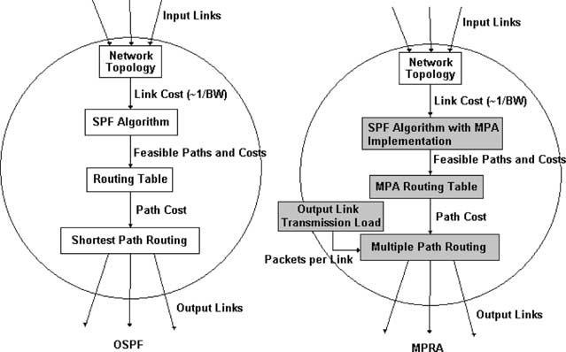
834

M. Rios et al. / Computer Communications 28 (2005) 829–836

Table 5
Balanced network results
Parameter

Throughput
Delay
Data load
Packets dropped

OSPF

387.35
56.94
0.27
240.69

OSPF with
MPRA
468.08
47.8
0.33
212.31

% Variation

20.84
K16.05
22.22
K11.79

Max. delay/pack
438,339.39 454,502.88
3.7

Ave. occupied buff. spc. 4637.96
3575.66
K22.9

Fig. 6. Node model for MPRA.

The model is calculated for every packet destination. The
pseudocode that formally describes the MPRA algorithm is
as follows:

Hop_routing_choose_hop(packet) {
IF (packet_arrived(packet)){
Minimum_costZInﬁnity;
dZpacket_destination(packet);
IF (packet_is_at_destination(d)) {
END;
} ELSE {
hopZread_MPA_table(d);
WHILE (hop) {
costZread_route_cost_MPA_table(hop, d);
hop_costZ
read_hop_cost_MPA_table(hop,d);
number_of_packetZ
read_number_of_packet_in_queue(hop);
total_costZhop_cost*number_of_pack-
etsCcost;
IF (total_cost!minimum_cost) {
Minimum_costZtotal_cost;
Next_hopZhop;
}
hopZread_MPA_table (d);
}
}
}
RETURN (next_hop);

Table 4
Simulated networks
No. of nodes No. of node pairs No. of networks

It is observed in the pseudocode, within the while
loop, the implementation of Eq. (17). As it was pointed
out in Fig. 3, MPRA performs exactly like OSPF, while
moving following the optimum cost versus path curve up
until point b is reached, where an alternative path to the
destination exist but with lower incremental cost. Of
course alternate paths are also carrying trafﬁc to other
destinations, so MPRA has to look through all feasible
alternate paths in order to ﬁnd if there exist one with
lower cost.

5.1. Discussion

MPRA is aimed to obtain a good but not exact routing
solution, because of its use of local information only. This
was chosen that way so as to ease the MPRA implemen-
tation by using all the information OSPF is using.

6. Computer experience

The MPRA algorithm was compared with the OSPF
protocol through computer simulation. The Random
Topology Generator and Graphical Previewer (RTG) [13]
was adapted and used to perform the network topology
simulation. Furthermore, the MaRS routing testbed [14,15]
was used to test networks using the OSPF protocol and then,
with the appropriate modiﬁcations, to test the MPRA
algorithm. Several network were simulated, as shown in
Table 4.
Every network was tested 10 times to ensure the results
conﬁdence. In all 3800 networks were tested.

Table 6
Unbalanced network results

communicating
Unbalanced networks (different bandwidth on links)
Parameter
OSPF
OSPF with
MPRA
% Variation

1–10
11–20
25
30
1–10
1–20
10
10
100
100
10
10
Throughput
Delay
Data load
Packets dropped
193.85
166.60
0.23
790.68
245.46
133.63
0.31
444.30
26.63
K19.79
33.82
K43.81

Balanced networks (same bandwidth on all links)
Max. delay/pack
1,973,619.98 1,682,846.54 K35.08

1–15
1–10
150
Ave. occupied buff. spc. 5125.53
4385.75
K14.73

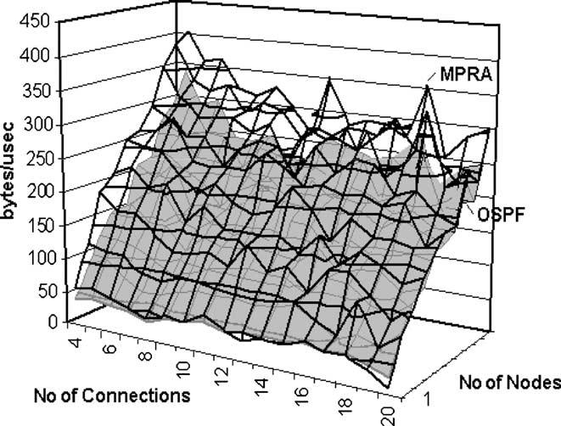
M. Rios et al. / Computer Communications 28 (2005) 829–836

Fig. 7. Throughput versus N of nodes.

The parameters measured in the simulations were the
following: Fig. 9. Dependence of throughput on connections and nodes.

(a) Throughput, the number of successfully received data

835

bytes through a time interval over the time interval
considered.
(b) Delay, average delay for all the successfully received
data packets.
(c) Data load, as a fraction of the network capacity.
(d) Packets dropped, discarded by the nodes.
(e) Maximum Delay per Packet, in the time interval.
(f) Average occupied buffer space, on the network queues.

Both balanced (that is, all links of the network have the
same cost) and unbalanced networks were studied, the
average results for all the networks are shown in Tables 5
and 6.
It is apparent from the results that OSPF works better with
the MPRA algorithm especially with unbalanced networks,
where an improvement of around 30% can be achieved. Even
with balanced networks a 15–20% improvement can be
reached in all parameters but the maximum delay per packet.
The following ﬁgures show other results, considering the
number of nodes and number of established connections.

Fig. 8. Throughput over number of connections.
Fig. 7 shows that MPRA improvement over OSPF is
almost independent on the number of nodes. Fig. 8 shows
that MPRA is more efﬁcient than OSPF when the number of
connections increases.

Fig. 10. Packet delay versus number of nodes.

Fig. 11. Packet delay versus number of connections.

836

M. Rios et al. / Computer Communications 28 (2005) 829–836

Fig. 9 shows the throughput related to the combination of
nodes and connections. It is observed that in all cases
MPRA works better than OSPF.
Figs. 10 and 11 show the dependence of the packet delay
on the number of nodes and connections, respectively.
Again MPRA provides lower delays than OSPF.

7. Conclusions

A new Multiple Path Routing Algorithm (MPRA) has
been presented, which improves on the OSPF routing
algorithm used in the Internet. The improvements are based
on balancing the trafﬁc load among one or several available
alternate paths to the destination, and avoiding network
loops.
The MPRA algorithm uses local node information to
dynamically adjust to changes in the network. A cost model
has been proposed that serves to efﬁciently choose among
alternate paths.
The MPRA algorithm in simulation conditions provides
throughput improvements on the order of 30% for
unbalanced networks and of 20% for balanced networks.
For future work, the development of more exact models
to evaluate the total path route to the destination should be
addressed. MPRA uses only a cost model for the next hop
output link and do not consider possible congestion
problems that may present at other nodes in the network.
The MPRA routing algorithm is a simple and efﬁcient
method, which looks for a local optimum solution, and
provides with better results when compared with the OSPF
routing algorithm.

Acknowledgements

This research was supported in part by funds from
Fondecyt (project 1040577).

References

[1] Internetworking Technology Handbook: Internet Protocols (IP). Cisco
Systems, Inc., 2002.
[2] Internetworking Technology Handbook: Open Shortest Path First
(OSPF). Cisco Systems, Inc., 2002.
[3] P. Narvaґez, K. Siu, H. Tzeng, New dynamic algorithms for shortest
path tree computation, IEEE/ACM Transactions on Networking
(TON) 8 (6) (2000) 734–746.
[4] P. Narvaґez, K. Siu, H. Tzeng, New dynamic SPT algorithm based on a
ball-and-string model, IEEE/ACM Transactions on Networking
(TON) 9 (6) (2001) 706–718.
[5] C. Wai-Kai, Theory of Nets: Flows in Networks, Wiley, New York,
1990.
[6] A. Kershenbaum, Telecommunications Network Design Algorithms,
McGraw-Hill International, New York, 1993.
[7] J. Moy, Open Shortest Path First IGP (OSPF). http://www.ietf.org/
html.charters/ospf-charter.html.
[8] Microsoft Corporation. Archives of OSPF@DISCUSS.MICROSOFT.
COM. Mailing list, 1997.
[9] J. Moy, OSPF version 2. Ascend Communications, Inc. RFC 2328,
April 1998.
[10] E. Dijkstra, A note two problems in connection with graphs,
Numerical Mathematics 1 (1959) 269–271.
[11] L. Kleinrock, Queueing systems, Theory, vol. 1, Wiley Interscience,
New York, 1970.
[12] L. Kleinrock, Queueing systems, Computer Applications, vol. 2,
Wiley Interscience, New York, 1970.
[13] L. Wei, Random Topology Generator (RTG). University of Southern
California, Los Angeles, CA. Available at: http://netweb.usc.edu/
daniel/research/sims/topology/.
[14] C. Alaettinoglu, A. Udaya Shankar, K. Dussa-Zieger, I. Matta, Design
and implementation of MaRS: a routing testbed. Technical Report,
CS-TR-2964, Department of Computer Science, University of
Maryland, Sept 1992, available at http://citeseer.nj.nec.com/alaetti-
noglu92design.html.
[15] A.U. Shankar, C. Alaettinoglu, K. Dussa-Zieger, I. Matta, Perform-
ance comparison of routing protocols under dynamic and static ﬁle
transfer connections, ACM SIGCOMM Computer Communication
Review 22 (5) (1992) 39–52.
[16] L.J. LeBlanc, R. Reddoch, J. Chifﬂet, P. Mahey, Performance of the
ﬂow-deviation algorithm for telecommunication routing with non-
standard assumptions, Informs 1995; TD28.1.
[17] D. Bertsekas, R. Gallager, Data Networks, second ed., Prentice-Hall,
Englewood Cliffs, NJ, 1992.

